No 2 Company 10th (V) Battalion, The Parachute Regiment

Service from October 1972 to April ‘76

Andrew John Selfe 24296552

I was studying in London in ’72 and answered an advertisement in the Daily Mirror to join the Parachute Regiment part-time. I had done National Service in 1 Special Service Battalion, an Armoured car unit in Tempe, Bloemfontein, South Africa in ’69 and ’70. We were next-door to ‘the Parabats’ and saw what they went through, so I went in with no illusions.

A pal and I signed up at Croydon, had our heads filled with gung-ho talk, by the likes of L/Cpl Dave Vander (‘jumping out’er an aircraft’s better’n a woman’), Cpl Sandy Saunders, ex-Congo mercenary Pte Owen and PSI WOII Danny Haddon. We reported to Training Wing, then at White City.

Cadre 57 boasted 30 members on 17th October 72. We were under CSM AH Richer and after several weekends of training we were advised that our 2-week camp would be at Penhale – Bodmin from 2nd to 17th December. I was writing exams and managed the first week only, re-joining at the end of the second week at Crookham Camp and Aldershot for the Pre-Para selection. My pal and many others had fallen out by the end!

Posted to 2 Coy; through my previous training I was made radio operator from the beginning, first at Patrol level then, probably when L/Cpl Grummitt broke his back on a dry stone wall on Dartmoor, as Coy HQ operator, under Maj Donald Chappell. Very soon I was promoted to L/Cpl, unusual as I was a ‘penguin’ still. I was still at College and the earliest I could get to a Basic Parachute course at Abingdon was AVR 11/73, from 29th June to 13th July. In those two weeks, Sgt Sid Garrad made us all into 7-jump-wonders. The training was deeper than one realises, I can still fall off a moving vehicle or bicycle without injury. Fear Dispels Knowledge!

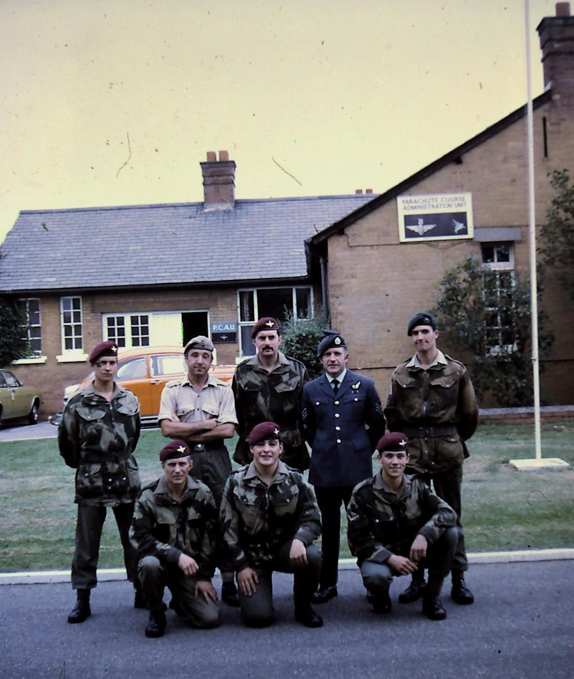

Taken outside Parachute Course Administration Unit RAF Abingdon

R. John Booth, ? Capt RAEC / SAS, Len Pepper, Sgt Sid Garrad, David Smith.
F. Ron Weaver, ? , L/Cpl Andy Selfe

The yearly cycle of exercises began, training at Patrol, Platoon, Company (Ex. Equinox in February), Batallion (Ex. Clarion Call in June) and Brigade levels; the run up to the Annual Brigade Shooting Competition with its Battle March and Shoot (Ex. Star Shoot at Coy level, Ex. April Capers at Bn, then Ex. Hot Shot in May at Bde). Other exercises came up in between. The year ended with Navigation at Brecon (Ex. Final Stride) in December.

In ’73, 2 Coy took part in and won the Bruneval Cup Brigade Medical Competition. I have vivid memories of carrying a tall Jock who overhung the stretcher at both ends around Thetford through the night; every now and then we’d disappear into a drainage trench!

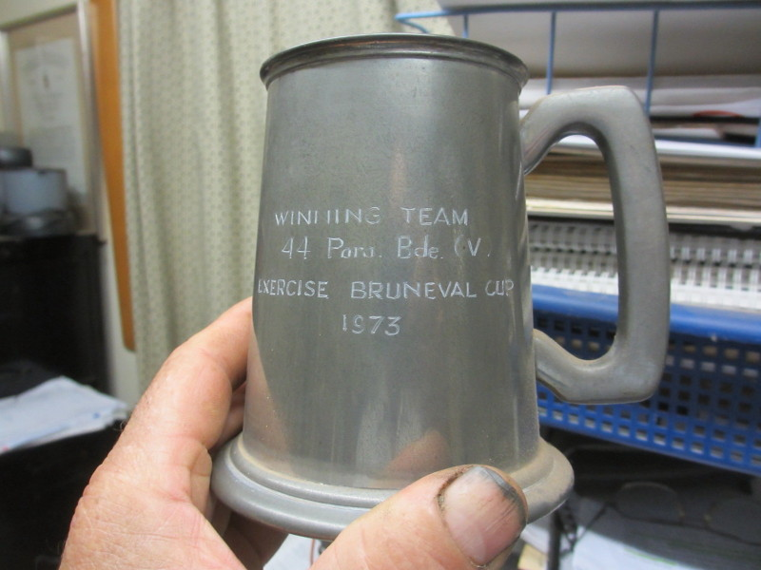

Tankard given to each of the members of the winning team.

It was a wonderful crowd to be mates with! It was a privilege serving under Maj Chappell, Lts John Power, Wills & Barton, CSM Jones, C/Sgt Cook (BEM), Sgts Poole and Berry, long-term Cpls Cooper (Stores) and Robertson (Weapons), Cpls Walker, Saunders, Vander, Lee (his father had been Colonel), Coldham, Lichfield, Farrell & Grummitt. Privates who spring to mind: Rayner & Butler (on Cadre 57 with me), ‘Steptoe’ Treslove, Owen, Budden, two Nunes’, Craven, Johnstone, Sheeley, Bennett, Spackman (Maj Chappell’s brother in law), Steel and many others. Several of these members rose in the ranks during my time.

Every year in late September, we went to Arnhem for a commorative clean-fatigue ‘jolly’ jump for the still very appreciative Dutch population. One year I took this photo on the way down. By luck I was facing the Memorial.

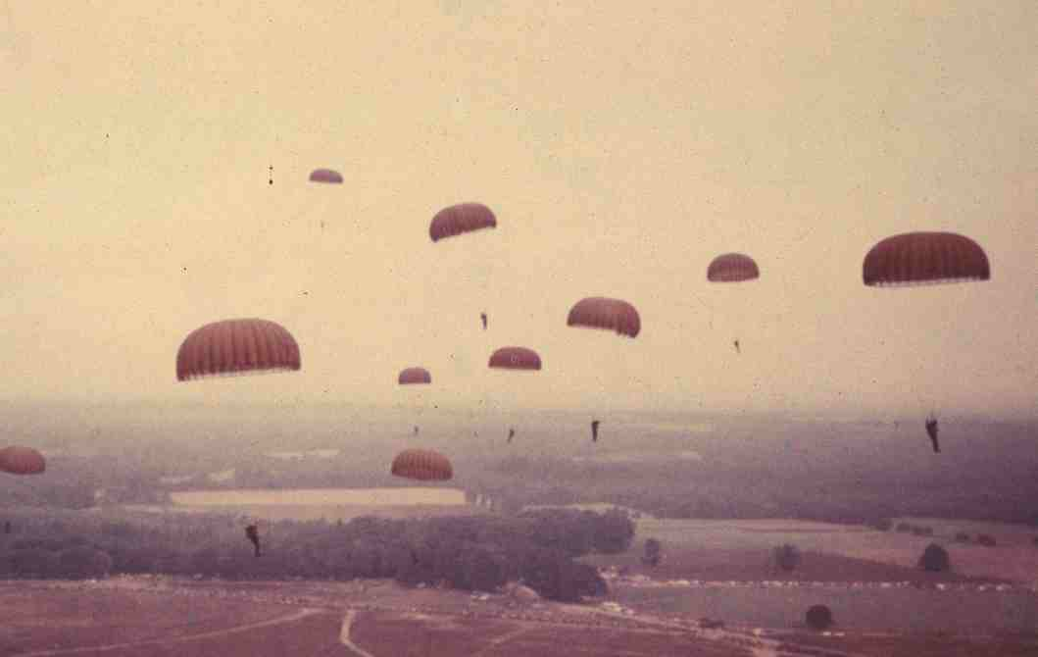

A lucky shot which I took during one of the descents at Arnhem. The Memorial is in the centre. Thousands of mainly Dutch people turned up to watch and get our autographs!

We used to fly into RNAF Deelen, draw and fit ‘chutes there and do the Jump, followed by mingling with the local population before going on a Battlefield Tour. One year we were accompanied by the legendary Sgt Tex Banwell who gave a graphic first-hand description of conditions during the battle at the Hartenstein Hotel.

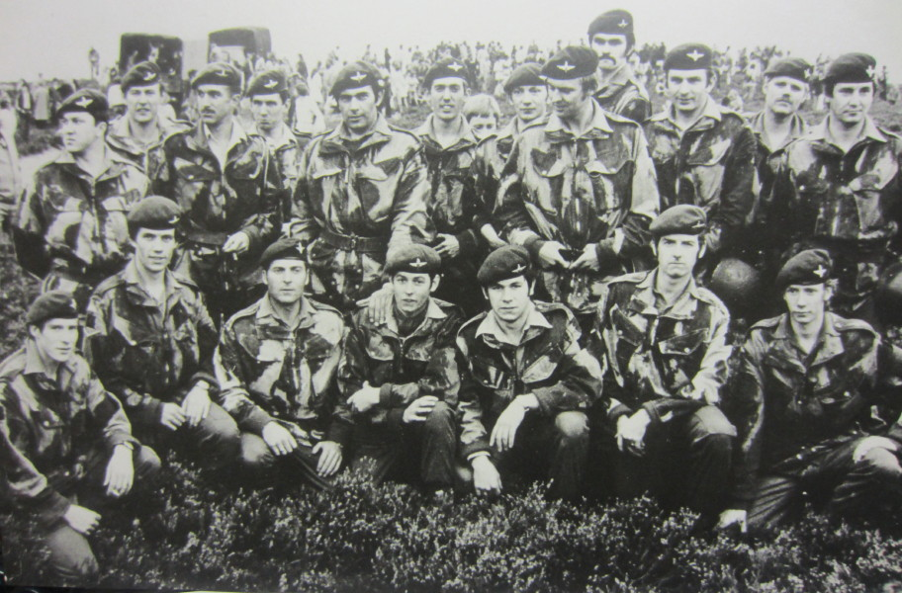

2 Coy on Ginkelse Heide

Standing: Higgs, Bennett, Capt Oliver, Lt Barton, Maj Chappell, Driscoll , L/Cpl Grummitt, Johnstone, Butler, ? , Cpl Coldham, ?.

F: Buckholt, L/Cpl Selfe, Owen, L/Cpls Lee, Litchfield & Farrell, Spackman.

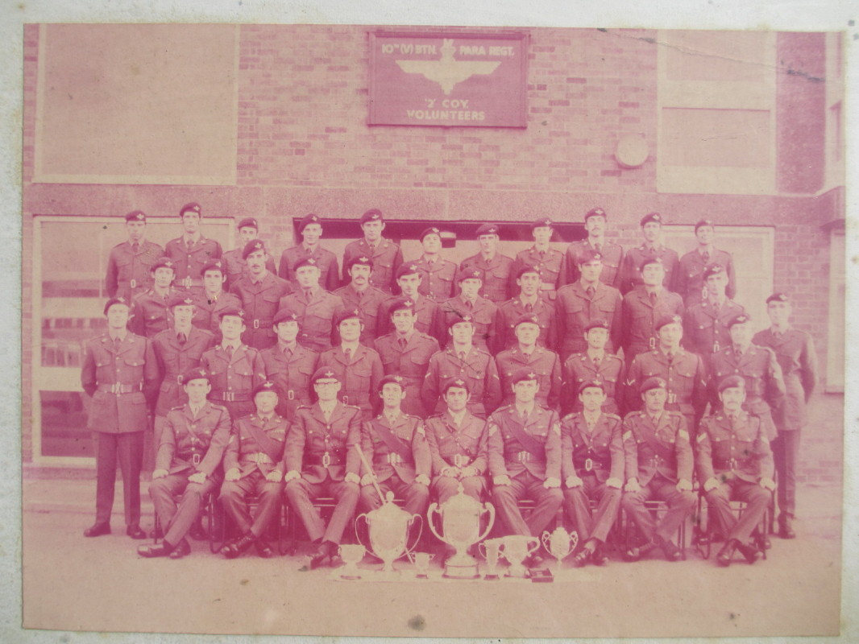

2 Coy at Croydon Barracks

Annual Camp from 29th September to 13th October ‘73 was at Rheinselen, about 80km south of Hamburg in those corrugated iron Nissen shacks! It was a great time to get stuck into real training and to get to know your mates better! Danny Haddon had retired as PSI and we had C/Sgt Ian Hutchinson in his place (on the right of Maj Chappell above).

The beginning of the second year was something of a let-down for me, with the same cycle of exercises beginning again. Up to then everything had been new. But that’s the way with training! I had finished at College by then and was working for CAV at Acton, although they were very accommodating regarding extra time off for Camp and courses. Still, 1974 saw 2 Coy winning the Brigade Battle March and Shoot competition.

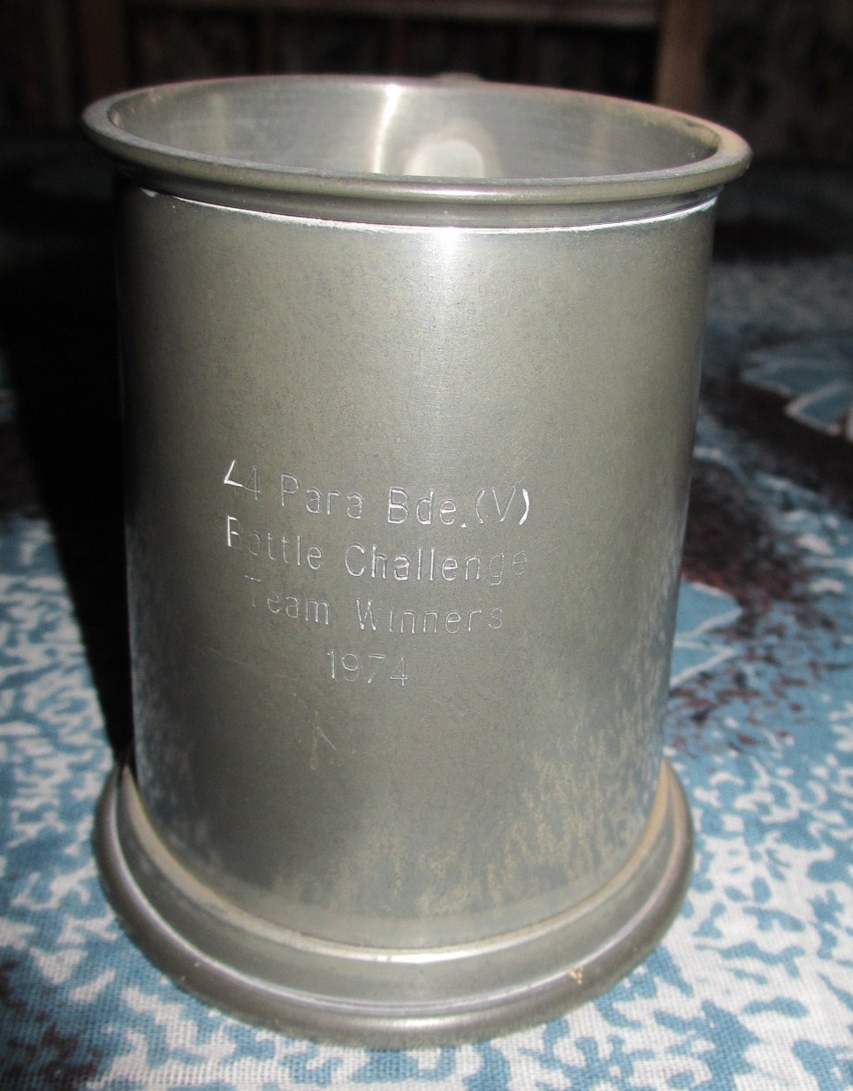

Tankard presented to members of the winning team in 44 (V) Bde Battle Challenge Competition, 1974.

Annual Camp in ’74 was at Sennelager, from 29th June to 13th July; a big change from the year before! In the preparation before Camp, those of us expecting to drive were given a course on how to drive on the wrong side of the road. Sennelager was a brick-built camp with historic barracks and about 25 shooting ranges, of which only one was a conventional Gallery Range! We got pretty fit during these camps and good at our jobs. Training led up to an exercise and in this, I gave up my Patrol to a Major Nick Sellers from the US 11th Special Forces Group and went back to being Radio Op in Coy HQ.

During winter we used to train for and take part in the Army Open Skiing Competition, travelling by train several times a year to Aviemore. The slopes we used were not very taxing, and mostly involved pointing skis straight down the hill and going as fast as possible!
Lt Gerald Oliver had joined 2 Coy as 4 Pl commander some time before September ’74, and later took over as OC 2 Coy as Captain. I was sent to Training Wing for from September ’74 to help train Cadres 66 and 67, returning to 2 Coy strength in March ’75. This did not excuse one from the normal Company training! Instead of training every second weekend it became every one!

Two exercises close together during ’75 are worthy of note; at the end of May we flew to Italy for a long week-end to learn to use the United States T10 parachute, with their 1/509th Airborne Battalion, then the only US Airborne unit stationed in Europe. They were stationed at Camp Ederle near Vicenza. We jumped out of a HU1H Huey helicopter and were awarded our US parachuting wings. We spent the evening in Venice eating and drinking too much! We flew back and dropped in on Kirton-in-Lindsey in hairy conditions. The Padre was carted off in an ambulance!

At the end of July we were back in Germany for a week-end exercise with 272 Fallschirmjäger, doing a night descent on Aschenmoor.

In May ‘75, some bright spark decided we should win the Devizes to Westminster Canoe Race, and then disappeared. However, the seed was planted. This non-stop 125-mile (200km) race, including 77 locks to portage, is supposed to be the longest of its kind in the world. As usual there was a good crowd to start with (no less than 21!), gradually dwindling down to the die-hards; in this case, Capt Gerald Oliver and me. The Race is over the Easter week-end and as one can’t paddle against the incoming Thames tide from Teddington onwards, you have to choose your start time accordingly. This was a tall order for us as the whole race took us 28 hours and 12 minutes! We were supported all the way by members of 2 Coy with food and encouragement during the infrequent stops. Going through the tunnel in the Savernake Forest and avoiding the weir at Marlow are things which stick out in my memory. There was a very long portage at the time at the top of the Kennett & Avon Canal as many of the locks were dry. We managed to finish 26th, and even won a medal!

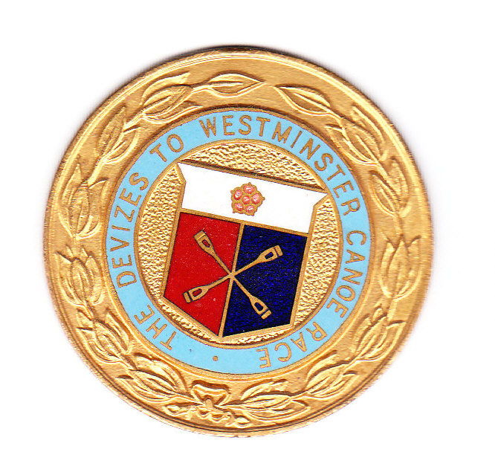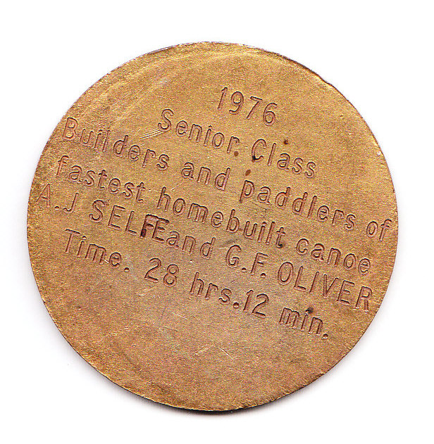

Medal won by Capt G F Oliver and O/Cdt A J Selfe for the fastest home-built canoe to finish the race!

I stayed in contact with Major Sellers from the US Special Forces and started inquiring, from October ’74 onwards, into the possibility of Cpl Saunders and myself visiting them and, as he had done with us, taking part in their Annual Camp. At the end of the year I was told that Company C, First Batalion, 11th Special Forces Group (Airborne) planned to train from 14th to 28th June ‘75 in the Allegheny Forest in Western Pennsylvania. It wasn’t easy to organise and I have correspondence right up to 10th June regarding permission, transport and pay. Sandy Saunders couldn’t make it, but I was waiting at Brize Norton and was forbidden to board the RAF VC10 because of some technicality. The flight left, but I still didn’t give up and by phoning our Training Major Chris Keeble, managed to get that permission. By luck, the plane came back shortly afterwards with a technical problem and I was allowed to board!

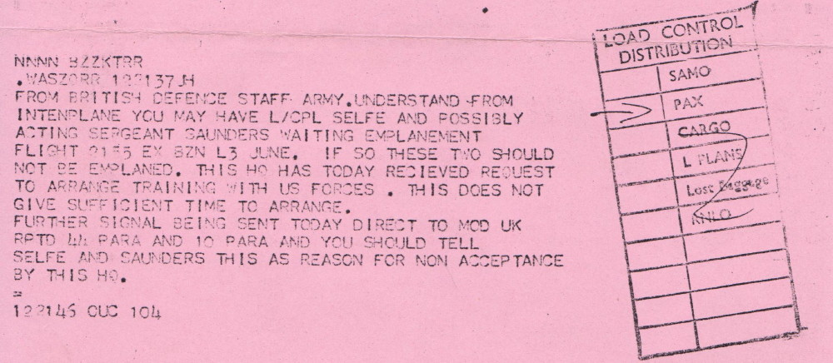

Forbidden to board the RAF VC10!

The training was suppposed to start with a night parachute infiltration but because of a typical SNAFU, parachutes were left behind and when we came to emplane we were asked where our parachutes were! Instead we went in by vehicle. The exercise included a long march with heavy equipment across very undulating country to an RV above our target. We kept it under observation for several days while we planned and carried out our attack on the bridge at the small town of Slate Run on Pine Creek.

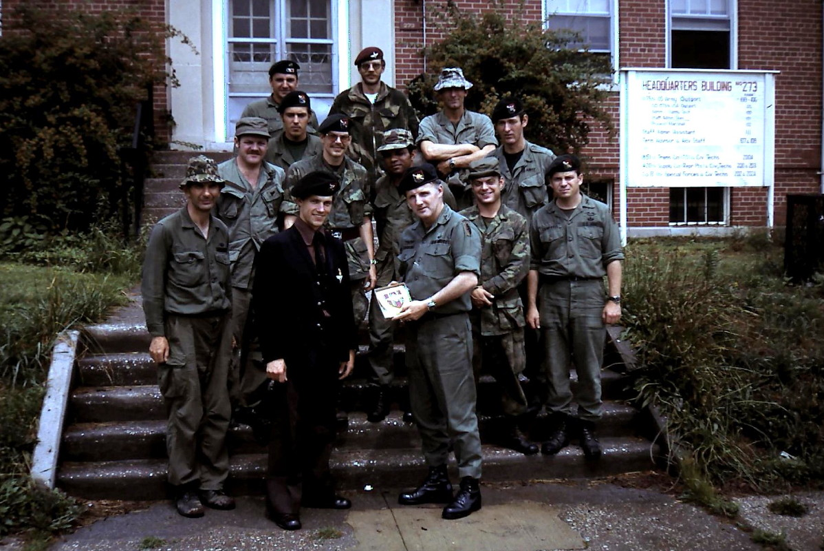

L/Cpl Selfe handing a Parachute Regiment shield to Maj Thomas Fanning, commander of Co C, 1st Bn, 11 Special Forces Group (Abn).

R: ? , SSG Martin (with ‘traded’ denison smock & red beret), MSG Hoppe
F: SSG Weston, ? , Sgt Eckert, Sgt Adams, S4 Hazzard, SFC van Aken, Cpt Duffy, Lt Campbell.

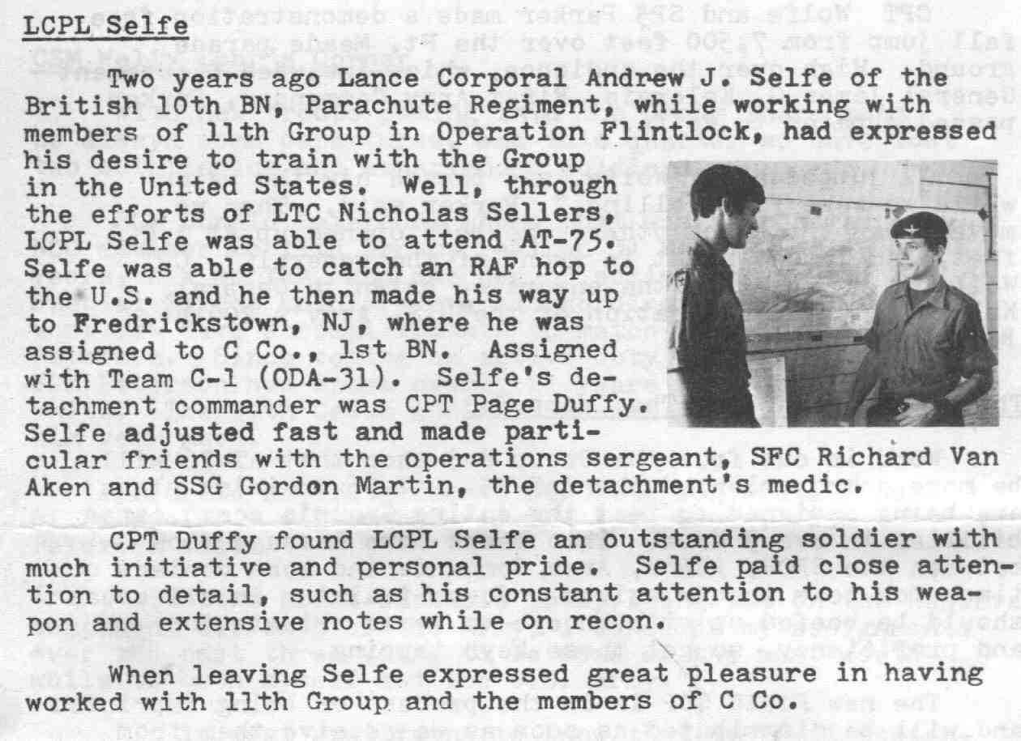

Extract from ‘The Arrowhead’ of September ‘75

On 20th August ’75 I went before a Unit Selection Board at White City, consisting of Majors D. Forbes, C. Keeble and D. Chappell. I was successful and was appointed as Officer Cadet.

Annual Camp from 30th August to 13th September ’75 was at Catterick. We were billeted at Bellerby. It was a new experience enjoying the privileges of the Officers’ Mess and very comfortable sleeping quarters!

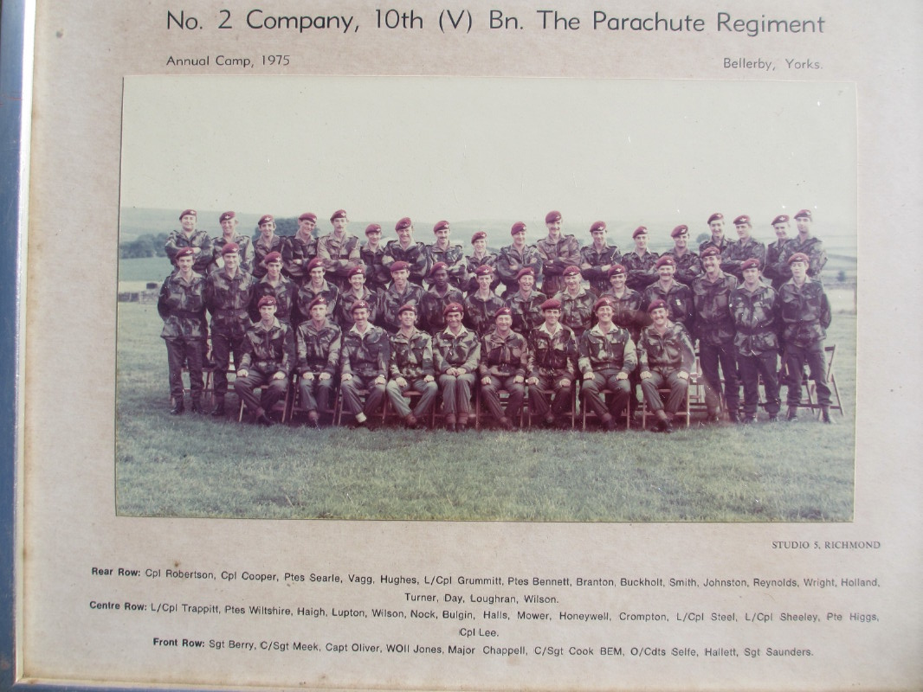

Company Photo

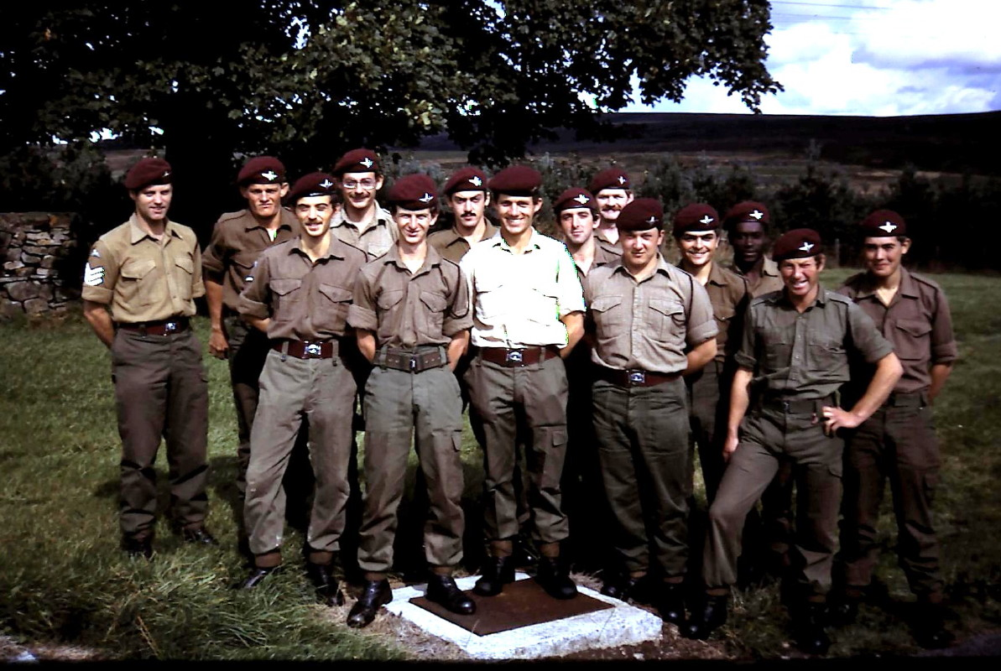

5 Platoon, 2 Coy, 10 Para, Catterick, September ‘75

R: Sgt Berry, Vagg, Hughes, Branton, Searle, Cpl Steel, Crompton, Bulgin, Haigh.

F: L/Cpl Trappitt, Halls, O/Cdt Selfe, Higgs, Mower.

Towards the end of ’75, I attended and passed a Patrol Commanders’ course at Brecon. I don’t remember much of the course, except the weather was what you would expect at place at that time of the year! One vivid memory is of an instructor asking one of our course-mates, “Aint yer never ‘urd uv the 7Ps? Proper Preparation and Planning Prevents Piss-Poor Performance!”

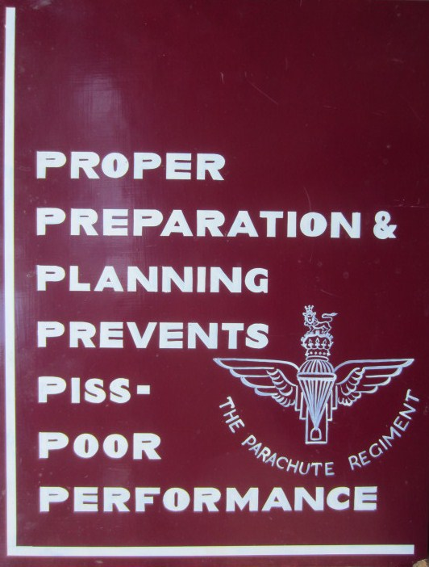

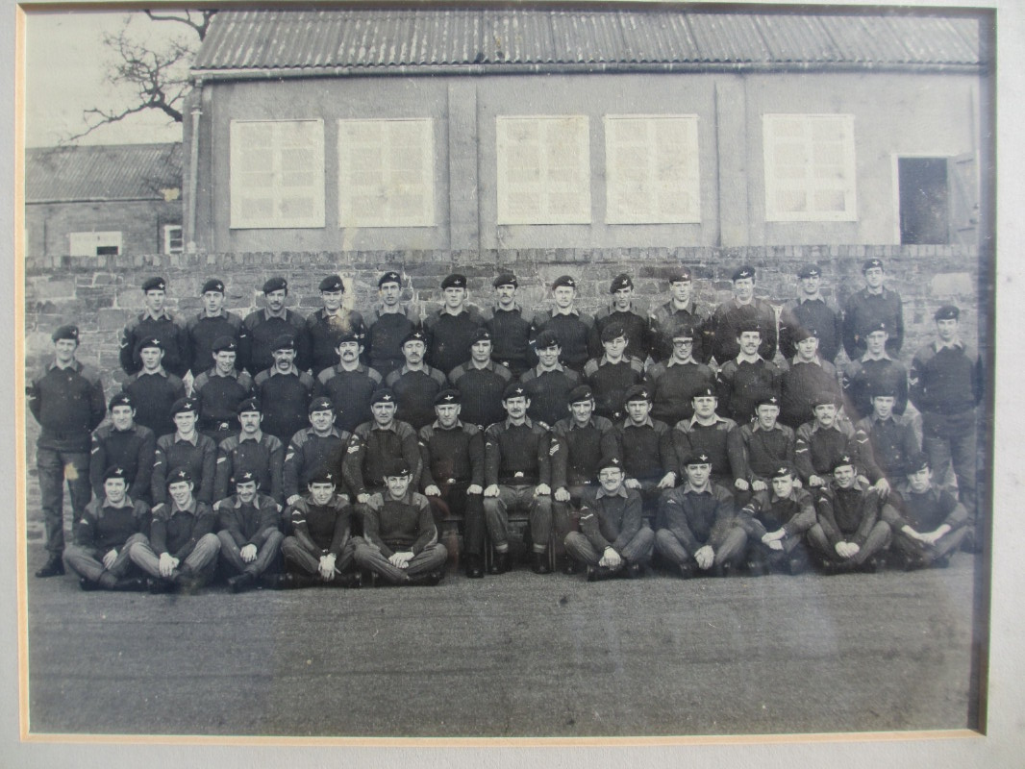

Officers, Instructors and successful candidates, Patrol Commanders Course, Dering Lines, Brecon, late ’75.

At the end of December ’75, Maj Chappell left us to take over at Finchley and Capt Gerald Oliver took over as OC 2 Coy. At the same time, it was decided that 2 Coy, which by then had an effective strength of less than 50, needed to increase its numbers and it was decided to establish 6 Pl at Hollyhedge House in Blackheath. I was chosen as Platoon commander and Cpls Sheeley and Trappitt as Pl Sgt and Pl Cpl respectively. Intensive recruiting drives were carried out to fill Cadres 71 and 72. We had to paint out and furnish the lecture rooms and make them look attractive for our new recruits. We sent out thousands of flyers by post and stood on the streets handing them out. The results were good to start with, and according to Geoff Butler, later exceeded our wildest hopes! “We had about 30 when I was Pl Sgt at Blackheath in ’81.”

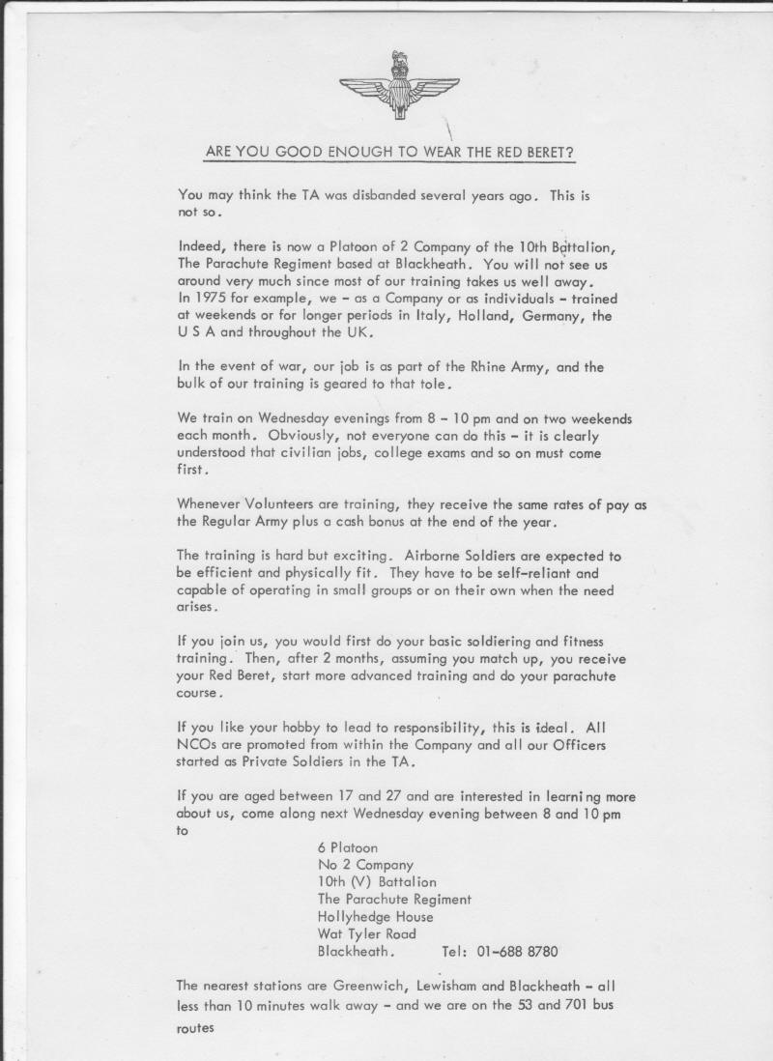

We handed out and posted thousands of these leaflets.

By this time, 2 Coy 10 Para was taking over every minute of my spare time. Tuesday was always drill night at Croydon (I remember missing only one which I could possibly have attended), Blackheath was Wednesday. There was plenty of organising to do on other evenings in the week. We were also practising for the Canoe Race on the Wey Navigation in the evenings after work. I hate to think how much of my work time was spent on the telephone on TA matters! I suspect the flyer above was copied on CAV’s machines. Every weekend was either Company training or at Training Wing. Apart from extra time I was allowed off for Camp by my firm, remaining leave was spent attending courses. I had already decided to leave UK and return to South Africa and this seemed to be the only way to ‘make a break’ from the Territorial Army, after 3½ years. I left in April ’76.

It had been an amazing experience! We travelled the length and breadth of the UK, except Northern Ireland, we visited Holland and Germany every year, we travelled to Italy and I was lucky enough to train in the United States as well. I met interesting people from many different walks of life and social standing; the Army made us all equals! Above all, it was a privilege to wear the Red Beret!

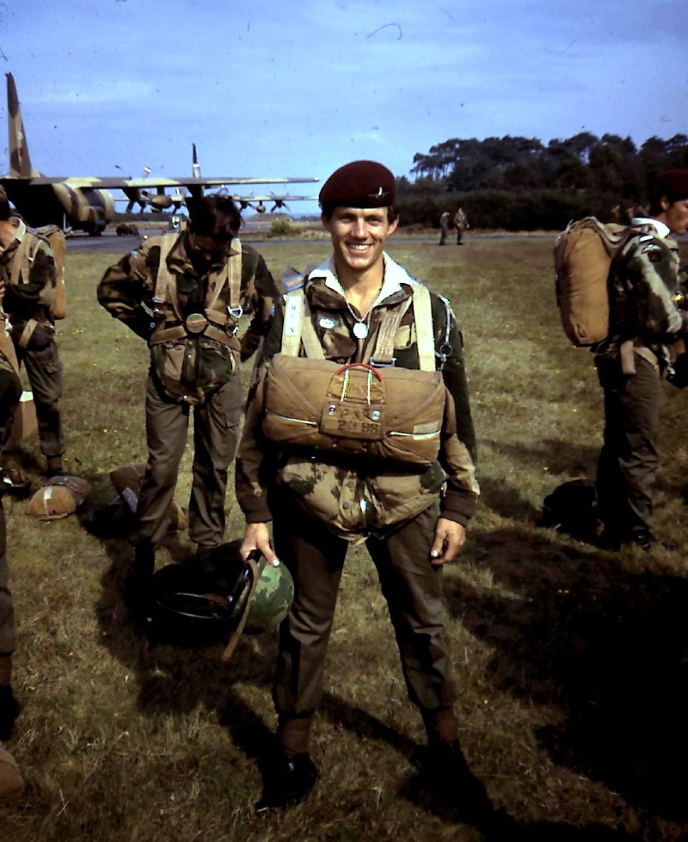

Drawing and fitting ‘chutes at RNAF Deelen 20th September ‘75

Andy Selfe, Elgin, Western Cape, South Africa.
Compiled from Orbats, Exercise Information sheets and letters in my posession, in December 2012

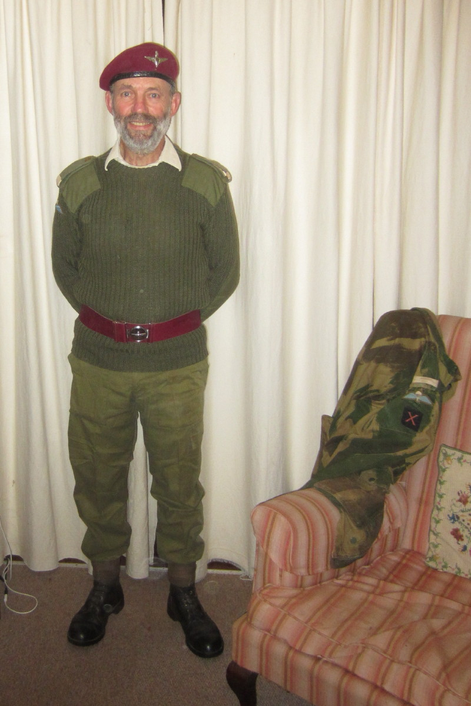

At home in 2012.

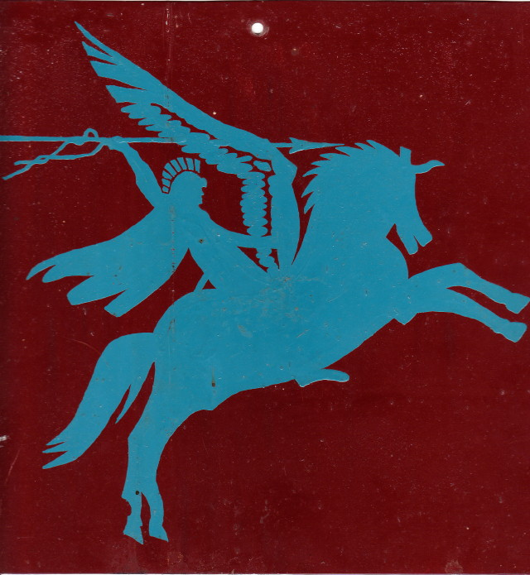

Pegasus vehicle unit plate

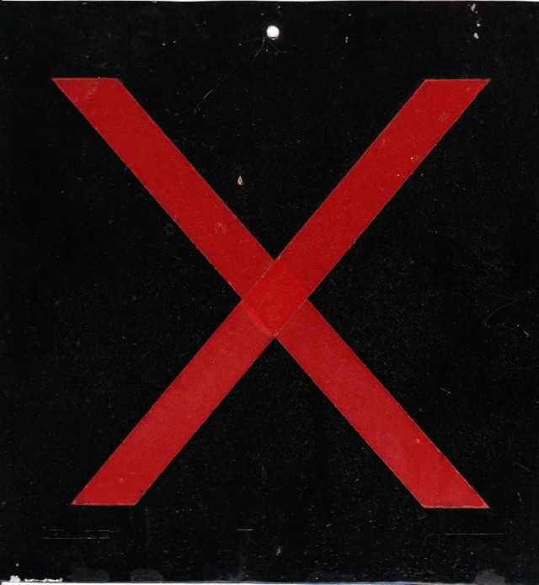

10 Para vehicle unit plate

